FAGUS SYLVATICA WITH PLOT
Initialization...
TASK: Exhaustive screening of candidate set.
Fitting...

After 50 models:
Best model: RespCorrectedWeight_GrCO2_KGr_Year~1+DiamClass+Class+T3+DensityKgM3
Crit= 11461.7137446509
Mean crit= 11739.6071401484
Completed.
glmulti.analysis
Method: h / Fitting: rma.glmulti / IC used: aicc
Level: 1 / Marginality: FALSE
From 64 models:
Best IC: 11456.9685958706
Best model:
[1] "RespCorrectedWeight_GrCO2_KGr_Year ~ 1 + DiamClass + Class + "
[2] " T3 + DensityKgM3 + Plot...16"
Evidence weight: 0.476092148502232
Worst IC: 12008.5073455457
2 models within 2 IC units.
4 models to reach 95% of evidence weight.
Models
1 RespCorrectedWeight_GrCO2_KGr_Year ~ 1 + DiamClass + Class + T3 + DensityKgM3 + Plot...16
2 RespCorrectedWeight_GrCO2_KGr_Year ~ 1 + DiamClass + Class + T3 + Soil_moist + DensityKgM3 + Plot...16
aicc weights
1 11456.97 0.4760921
2 11457.85 0.3065560

summary(res@objects[[1]])

Mixed-Effects Model (k = 1394; tau^2 estimator: ML)

logLik deviance AIC BIC AICc ​
-5721.4439 11442.8878 11456.8878 11493.5673 11456.9686

tau^2 (estimated amount of residual heterogeneity): 115.4260 (SE = 4.6659)
tau (square root of estimated tau^2 value): 10.7436
R^2 (amount of heterogeneity accounted for): 44.19%

Test of Moderators (coefficients 2:6):
QM(df = 5) = 674.9138, p-val < .0001

Model 1 Results:

estimate se zval pval ci.lb ci.ub ​
intrcpt 1.7192 2.3694 0.7256 0.4681 -2.9247 6.3632
DiamClass 0.4725 0.0361 13.1004 <.0001 0.4018 0.5432 ***
Class 0.7031 0.3048 2.3066 0.0211 0.1057 1.3005 *
T3 0.7126 0.0372 19.1824 <.0001 0.6398 0.7855 ***
DensityKgM3 -0.0113 0.0027 -4.2117 <.0001 -0.0166 -0.0060 ***
Plot...16 -0.3559 0.1368 -2.6013 0.0093 -0.6241 -0.0878 **

Model 2
summary(res@objects[[2]])

Mixed-Effects Model (k = 1394; tau^2 estimator: ML)

logLik deviance AIC BIC AICc ​
-5720.8725 11441.7450 11457.7450 11499.6645 11457.8490

tau^2 (estimated amount of residual heterogeneity): 114.9494 (SE = 4.6476)
tau (square root of estimated tau^2 value): 10.7214
R^2 (amount of heterogeneity accounted for): 44.42%

Test of Moderators (coefficients 2:7):
QM(df = 6) = 677.6575, p-val < .0001

Model Results:

estimate se zval pval ci.lb ci.ub ​
intrcpt 3.8062 3.0655 1.2416 0.2144 -2.2021 9.8145
DiamClass 0.4752 0.0361 13.1593 <.0001 0.4044 0.5459 ***
Class 0.7215 0.3047 2.3675 0.0179 0.1242 1.3188 *
T3 0.7033 0.0380 18.4932 <.0001 0.6287 0.7778 ***
Soil_moist -0.0009 0.0009 -1.0712 0.2841 -0.0026 0.0008
DensityKgM3 -0.0109 0.0027 -4.0547 <.0001 -0.0162 -0.0056 ***
Plot...16 -0.3689 0.1371 -2.6899 0.0071 -0.6377 -0.1001 **

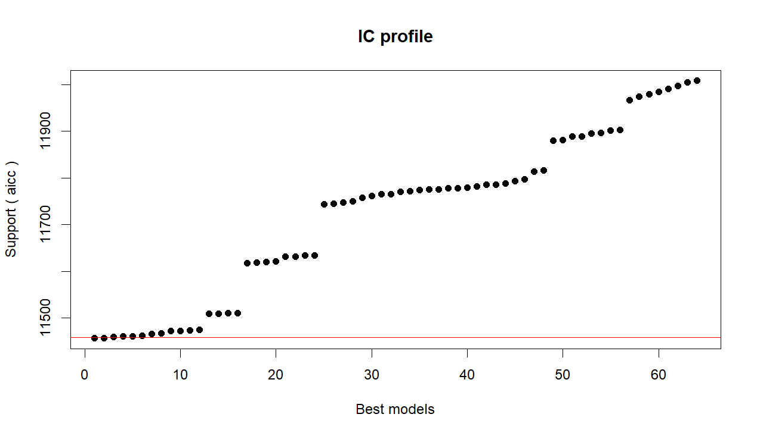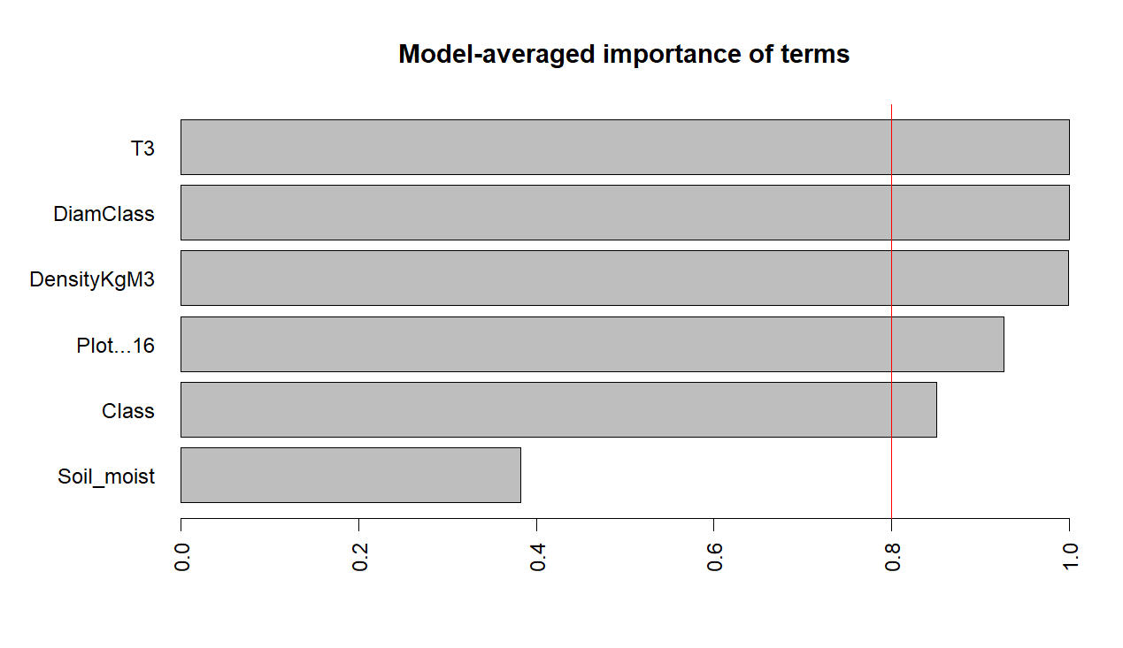
Estimate Uncond. variance Nb models Importance +/- (alpha=0.05)
Soil_moist -0.0003444287 3.696120e-07 32 0.3829014 0.001191574
Class 0.6089434723 1.343331e-01 32 0.8502685 0.718355855
Plot...16 -0.3380433007 2.393582e-02 32 0.9258073 0.303230061
DensityKgM3 -0.0116573182 8.738231e-06 32 0.9994316 0.005793751
intrcpt 2.9426377625 9.640699e+00 64 1.0000000 6.085585349
DiamClass 0.4704312706 1.379235e-03 32 1.0000000 0.072789239
T3 0.7093497741 1.426095e-03 32 1.0000000 0.074015437

Estimate Std. Error z value Pr(>|z|) ci.lb ci.ub Importance
intrcpt 2.9426 3.1049 0.9477 0.3433 -3.1429 9.0282 1.0000
DiamClass 0.4704 0.0371 12.6671 0.0000 0.3976 0.5432 1.0000
T3 0.7093 0.0378 18.7839 0.0000 0.6353 0.7834 1.0000
DensityKgM3 -0.0117 0.0030 -3.9435 0.0001 -0.0175 -0.0059 0.9994
Plot...16 -0.3380 0.1547 -2.1850 0.0289 -0.6413 -0.0348 0.9258
Class 0.6089 0.3665 1.6614 0.0966 -0.1094 1.3273 0.8503
Soil_moist -0.0003 0.0006 -0.5665 0.5710 -0.0015 0.0008 0.3829

Abies alba with plot
After 50 models:
Best model: RespCorrectedWeight_GrCO2_KGr_Year~1+DiamClass+Class+T3+Soil_moist+Plot...16
Crit= 10772.6929319852
Mean crit= 11036.5450404309
Completed.

glmulti.analysis
Method: h / Fitting: rma.glmulti / IC used: aicc
Level: 1 / Marginality: FALSE
From 64 models:
Best IC: 10772.6929319852
Best model:
[1] "RespCorrectedWeight_GrCO2_KGr_Year ~ 1 + DiamClass + Class + "
[2] " T3 + Soil_moist + Plot...16"
Evidence weight: 0.546157540223415
Worst IC: 11290.3862250759
2 models within 2 IC units.
1 models to reach 95% of evidence weight.
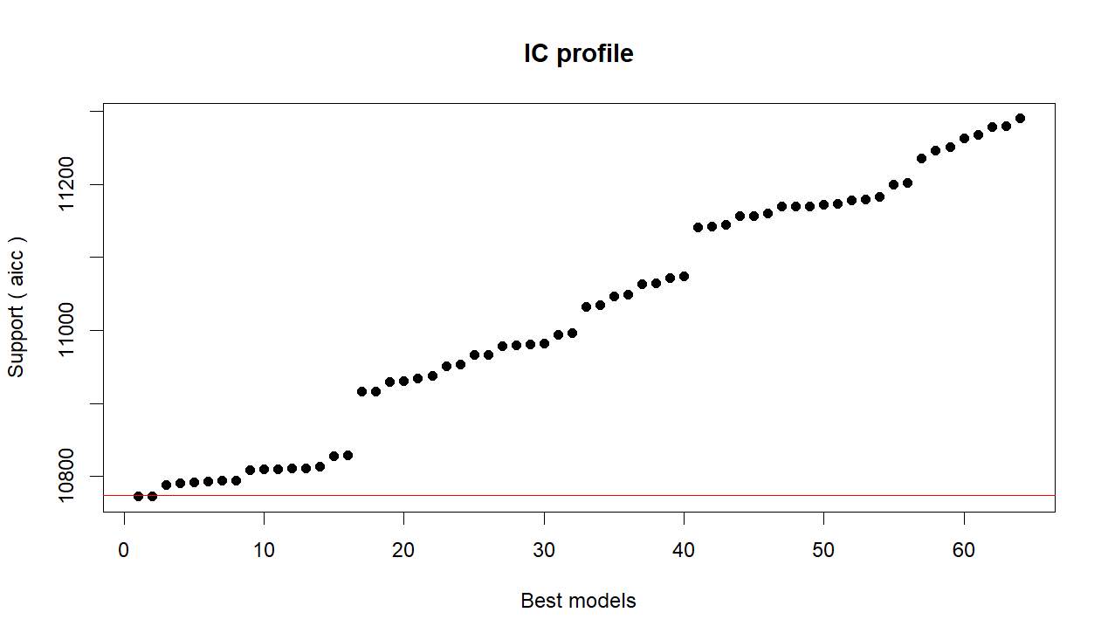
model
1 RespCorrectedWeight_GrCO2_KGr_Year ~ 1 + DiamClass + Class + T3 + Soil_moist + Plot...16
2 RespCorrectedWeight_GrCO2_KGr_Year ~ 1 + DiamClass + Class + T3 + Soil_moist + DensityKgM3 + Plot...16
aicc weights
1 10772.69 0.5461575
2 10773.06 0.4535409
Model 1 Results:

estimate se zval pval ci.lb ci.ub ​
intrcpt 5.1572 2.7022 1.9085 0.0563 -0.1390 10.4533 .
DiamClass 0.7238 0.0349 20.7504 <.0001 0.6554 0.7922 ***
Class 1.1632 0.2696 4.3139 <.0001 0.6347 1.6917 ***
T3 0.5342 0.0428 12.4723 <.0001 0.4503 0.6182 ***
Soil_moist -0.0047 0.0010 -4.8102 <.0001 -0.0066 -0.0028 ***
Plot...16 -0.7355 0.1512 -4.8631 <.0001 -1.0319 -0.4391 ***

Model 2 results
Model Results:

estimate se zval pval ci.lb ci.ub ​
intrcpt 2.4962 3.3953 0.7352 0.4622 -4.1586 9.1509
DiamClass 0.7588 0.0444 17.0995 <.0001 0.6718 0.8457 ***
Class 1.3426 0.3033 4.4262 <.0001 0.7481 1.9372 ***
T3 0.5327 0.0428 12.4522 <.0001 0.4489 0.6166 ***
Soil_moist -0.0047 0.0010 -4.8300 <.0001 -0.0067 -0.0028 ***
DensityKgM3 0.0037 0.0029 1.2867 0.1982 -0.0020 0.0095
Plot...16 -0.7034 0.1530 -4.5983 <.0001 -1.0033 -0.4036 ***

---
Signif. codes: 0 ‘***’ 0.001 ‘**’ 0.01 ‘*’ 0.05 ‘.’ 0.1 ‘ ’ 1
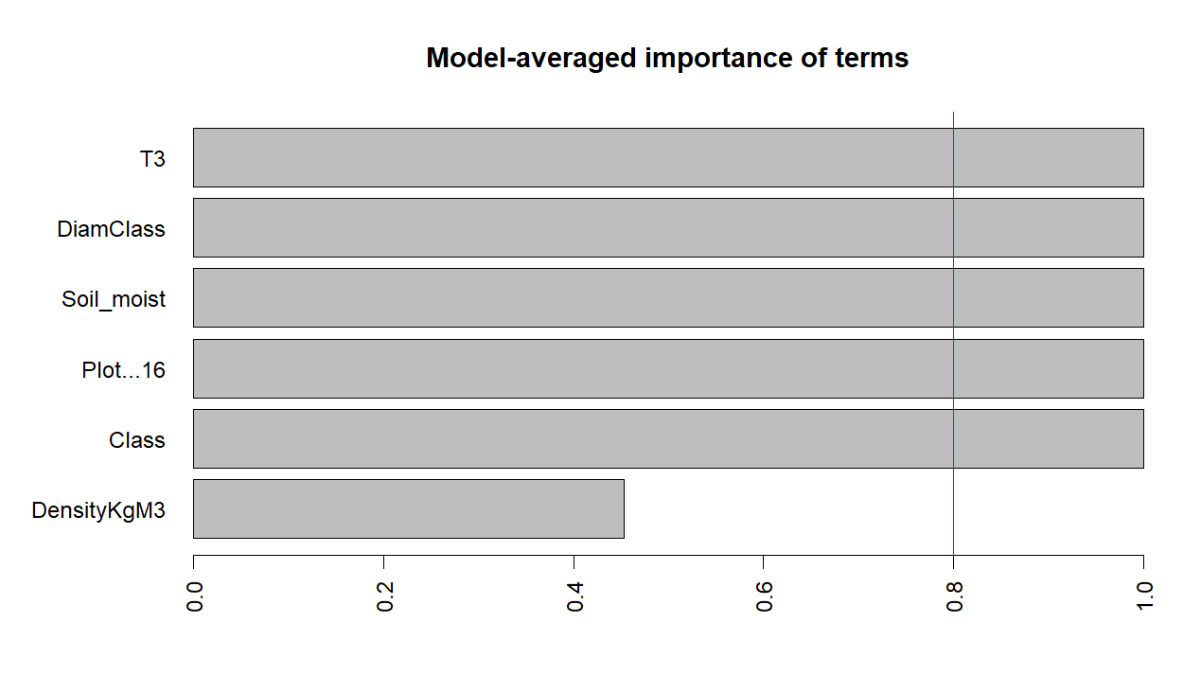

Estimate Std. Error z value Pr(>|z|) ci.lb ci.ub Importance
intrcpt 3.9504 3.2934 1.1995 0.2303 -2.5045 10.4053 1.0000
DiamClass 0.7397 0.0429 17.2601 0.0000 0.6557 0.8236 1.0000
T3 0.5335 0.0428 12.4612 0.0000 0.4496 0.6175 1.0000
Soil_moist -0.0047 0.0010 -4.8184 0.0000 -0.0067 -0.0028 1.0000
Plot...16 -0.7209 0.1529 -4.7153 0.0000 -1.0206 -0.4213 1.0000
Class 1.2443 0.2987 4.1655 0.0000 0.6588 1.8298 0.9998
DensityKgM3 0.0017 0.0025 0.6681 0.5040 -0.0033 0.0067 0.4537

Fagus sylvatica SCALED

Initialization...
TASK: Exhaustive screening of candidate set.
Fitting...

After 50 models:
Best model: RespCorrectedWeight_GrCO2_KGr_Year~1+DiamClass+Class+T3+DensityKgM3
Crit= -453.321647799428
Mean crit= -351.214370592998
Completed.
glmulti.analysis
Method: h / Fitting: rma.glmulti / IC used: aicc
Level: 1 / Marginality: FALSE
From 64 models:
Best IC: -473.772058266492
Best model:
[1] "RespCorrectedWeight_GrCO2_KGr_Year ~ 1 + DiamClass + Class + "
[2] " T3 + DensityKgM3 + Plot...16"
Evidence weight: 0.432349415026057
Worst IC: -249.480982021117
3 models within 2 IC units.
3 models to reach 95% of evidence weight.
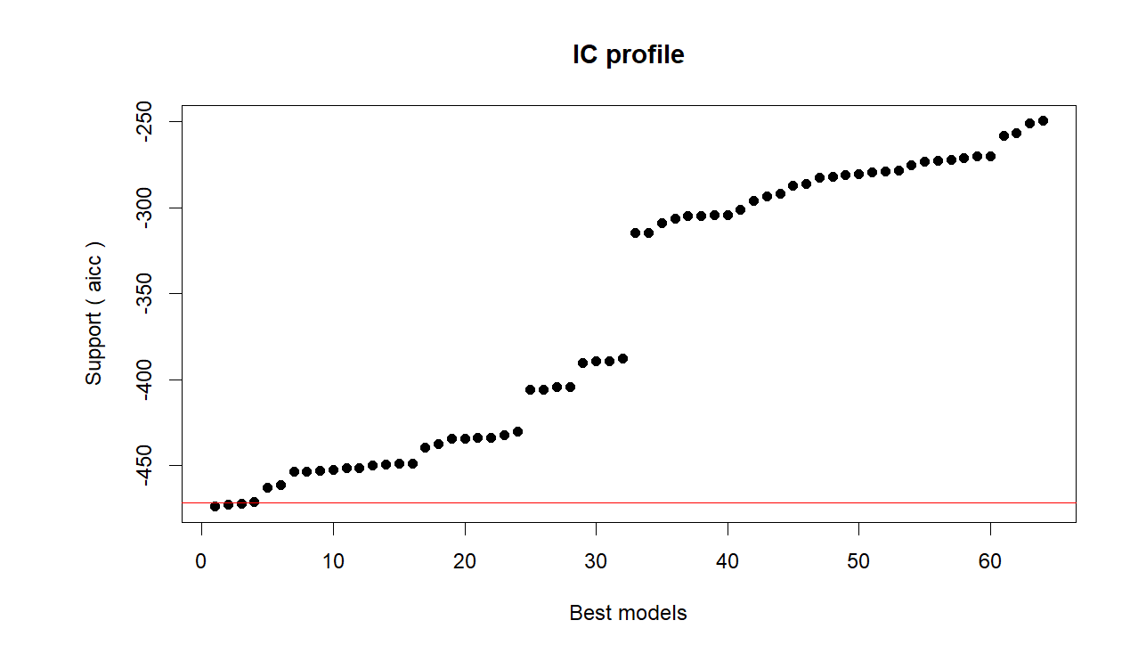
model
1 RespCorrectedWeight_GrCO2_KGr_Year ~ 1 + DiamClass + Class + T3 + DensityKgM3 + Plot...16
2 RespCorrectedWeight_GrCO2_KGr_Year ~ 1 + DiamClass + Class + T3 + Soil_moist + DensityKgM3 + Plot...16
3 RespCorrectedWeight_GrCO2_KGr_Year ~ 1 + DiamClass + T3 + DensityKgM3 + Plot...16
aicc weights
1 -473.7721 0.4323494
2 -472.7714 0.2621407
3 -472.0379 0.1816608

MODEL 1
Mixed-Effects Model (k = 1394; tau^2 estimator: ML)

logLik deviance AIC BIC AICc ​
243.9264 -487.8529 -473.8529 -437.1733 -473.7721

tau^2 (estimated amount of residual heterogeneity): 0.0130 (SE = 0.0006)
tau (square root of estimated tau^2 value): 0.1139
R^2 (amount of heterogeneity accounted for): 12.72%

Test of Moderators (coefficients 2:6):
QM(df = 5) = 241.9319, p-val < .0001

Model Results:

estimate se zval pval ci.lb ci.ub ​
intrcpt -0.3249 0.0038 -86.3460 <.0001 -0.3323 -0.3176 ***
DiamClass 0.0153 0.0042 3.5991 0.0003 0.0070 0.0236 ***
Class -0.0084 0.0043 -1.9400 0.0524 -0.0168 0.0001 .
T3 0.0549 0.0042 13.2380 <.0001 0.0468 0.0631 ***
DensityKgM3 -0.0251 0.0048 -5.2327 <.0001 -0.0345 -0.0157 ***
Plot...16 -0.0169 0.0035 -4.7693 <.0001 -0.0238 -0.0099 ***

---
Signif. codes: 0 ‘***’ 0.001 ‘**’ 0.01 ‘*’ 0.05 ‘.’ 0.1 ‘ ’ 1

MODEL 2
Mixed-Effects Model (k = 1394; tau^2 estimator: ML)

logLik deviance AIC BIC AICc ​
244.4377 -488.8753 -472.8753 -430.9559 -472.7714

tau^2 (estimated amount of residual heterogeneity): 0.0130 (SE = 0.0006)
tau (square root of estimated tau^2 value): 0.1138
R^2 (amount of heterogeneity accounted for): 12.77%

Test of Moderators (coefficients 2:7):
QM(df = 6) = 243.0314, p-val < .0001

Model Results:

estimate se zval pval ci.lb ci.ub ​
intrcpt -0.3248 0.0038 -86.2937 <.0001 -0.3322 -0.3175 ***
DiamClass 0.0157 0.0043 3.6771 0.0002 0.0073 0.0240 ***
Class -0.0082 0.0043 -1.8910 0.0586 -0.0166 0.0003 .
T3 0.0541 0.0042 12.7952 <.0001 0.0458 0.0624 ***
Soil_moist -0.0038 0.0038 -1.0112 0.3119 -0.0112 0.0036
DensityKgM3 -0.0245 0.0048 -5.0595 <.0001 -0.0340 -0.0150 ***
Plot...16 -0.0172 0.0036 -4.8459 <.0001 -0.0242 -0.0103 ***

---
Signif. codes: 0 ‘***’ 0.001 ‘**’ 0.01 ‘*’ 0.05 ‘.’ 0.1 ‘ ’ 1

MODEL 3
Mixed-Effects Model (k = 1394; tau^2 estimator: ML)

logLik deviance AIC BIC AICc ​
242.0492 -484.0984 -472.0984 -440.6588 -472.0379

tau^2 (estimated amount of residual heterogeneity): 0.0130 (SE = 0.0006)
tau (square root of estimated tau^2 value): 0.1141
R^2 (amount of heterogeneity accounted for): 12.35%

Test of Moderators (coefficients 2:5):
QM(df = 4) = 237.5758, p-val < .0001

Model Results:

estimate se zval pval ci.lb ci.ub ​
intrcpt -0.3247 0.0038 -86.1295 <.0001 -0.3321 -0.3173 ***
DiamClass 0.0181 0.0040 4.5132 <.0001 0.0102 0.0259 ***
T3 0.0549 0.0042 13.1928 <.0001 0.0467 0.0630 ***
DensityKgM3 -0.0196 0.0039 -5.0579 <.0001 -0.0272 -0.0120 ***
Plot...16 -0.0164 0.0035 -4.6316 <.0001 -0.0233 -0.0094 ***

---
Signif. codes: 0 ‘***’ 0.001 ‘**’ 0.01 ‘*’ 0.05 ‘.’ 0.1 ‘ ’ 1
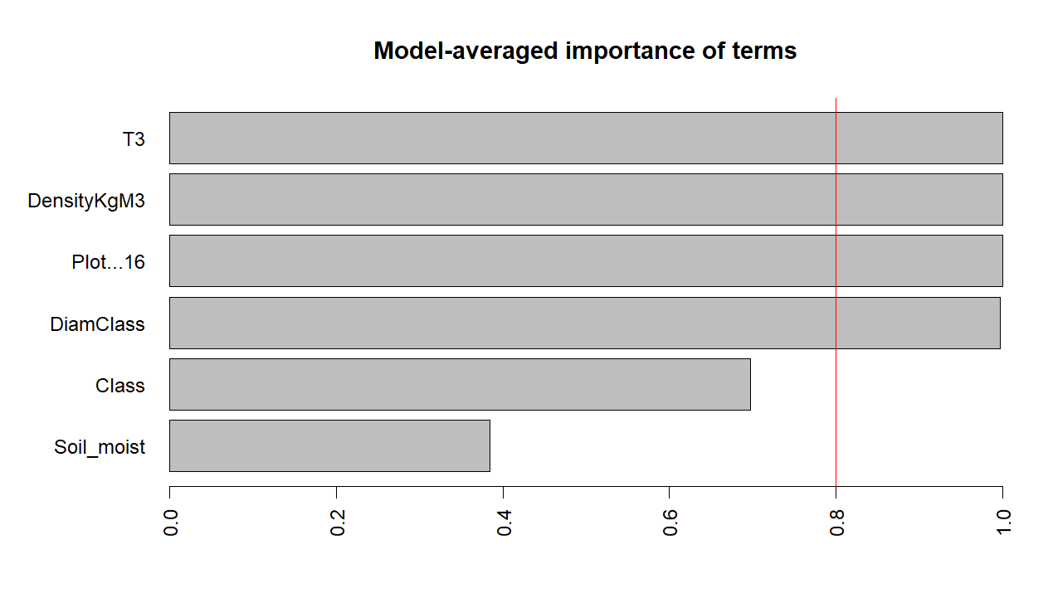
Abies Alba SCALED
Initialization...
TASK: Exhaustive screening of candidate set.
Fitting...

After 50 models:
Best model: RespCorrectedWeight_GrCO2_KGr_Year~1+DiamClass+Class+T3+Plot...16
Crit= -1431.3074638703
Mean crit= -1270.26696980732
Completed.
glmulti.analysis
Method: h / Fitting: rma.glmulti / IC used: aicc
Level: 1 / Marginality: FALSE
From 64 models:
Best IC: -1431.3074638703
Best model:
[1] "RespCorrectedWeight_GrCO2_KGr_Year ~ 1 + DiamClass + Class + "
[2] " T3 + Plot...16"
Evidence weight: 0.335210516953804
Worst IC: -1135.31259979506
3 models within 2 IC units.
6 models to reach 95% of evidence weight.
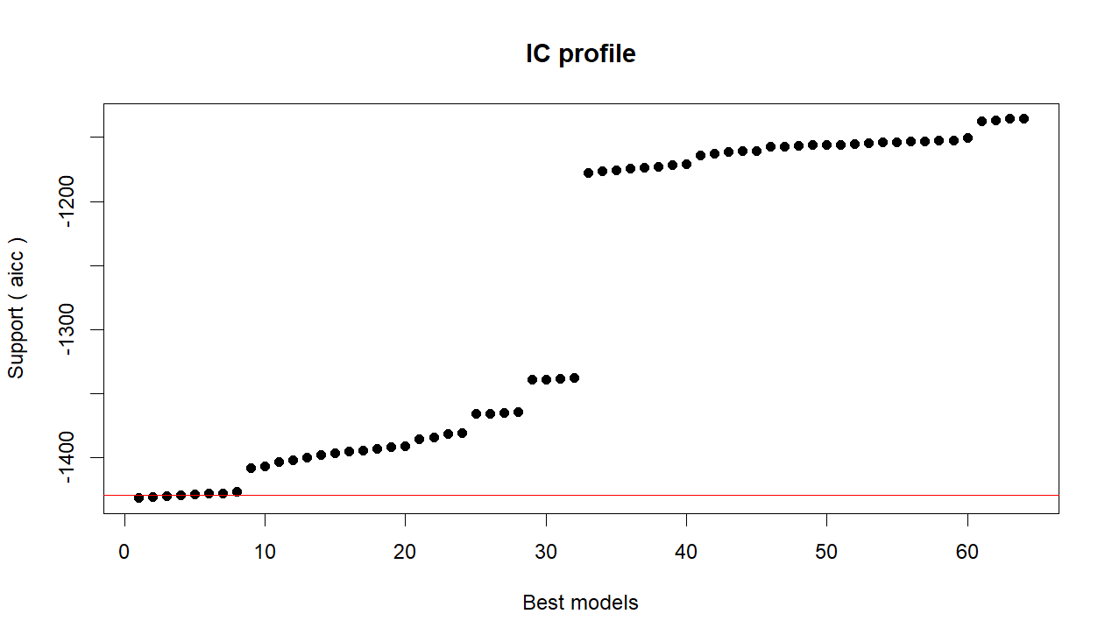

model
1 RespCorrectedWeight_GrCO2_KGr_Year ~ 1 + DiamClass + Class + T3 + Plot...16
2 RespCorrectedWeight_GrCO2_KGr_Year ~ 1 + DiamClass + Class + T3 + DensityKgM3 + Plot...16
3 RespCorrectedWeight_GrCO2_KGr_Year ~ 1 + DiamClass + Class + T3 + Soil_moist + Plot...16
aicc weights
1 -1431.307 0.3352105
2 -1430.125 0.1856060
3 -1429.623 0.1444119
Model 1
Mixed-Effects Model (k = 1283; tau^2 estimator: ML)

logLik deviance AIC BIC AICc ​
721.6866 -1443.3733 -1431.3733 -1400.4316 -1431.3075

tau^2 (estimated amount of residual heterogeneity): 0.0065 (SE = 0.0003)
tau (square root of estimated tau^2 value): 0.0807
R^2 (amount of heterogeneity accounted for): 21.36%

Test of Moderators (coefficients 2:5):
QM(df = 4) = 335.4726, p-val < .0001

Model Results:

estimate se zval pval ci.lb ci.ub ​
intrcpt -0.2885 0.0027 -107.7447 <.0001 -0.2937 -0.2832 ***
DiamClass 0.0242 0.0029 8.2806 <.0001 0.0185 0.0300 ***
Class 0.0150 0.0026 5.8516 <.0001 0.0100 0.0201 ***
T3 0.0474 0.0028 16.8988 <.0001 0.0419 0.0529 ***
Plot...16 -0.0051 0.0025 -2.0303 0.0423 -0.0101 -0.0002 *

---
Signif. codes: 0 ‘***’ 0.001 ‘**’ 0.01 ‘*’ 0.05 ‘.’ 0.1 ‘ ’ 1

MODEL 2
> summary(res@objects[[2]])

Mixed-Effects Model (k = 1283; tau^2 estimator: ML)

logLik deviance AIC BIC AICc ​
722.1065 -1444.2130 -1430.2130 -1394.1143 -1430.1252

tau^2 (estimated amount of residual heterogeneity): 0.0065 (SE = 0.0003)
tau (square root of estimated tau^2 value): 0.0807
R^2 (amount of heterogeneity accounted for): 21.45%

Test of Moderators (coefficients 2:6):
QM(df = 5) = 336.6350, p-val < .0001

Model Results:

estimate se zval pval ci.lb ci.ub ​
intrcpt -0.2886 0.0027 -107.7764 <.0001 -0.2938 -0.2833 ***
DiamClass 0.0223 0.0036 6.1560 <.0001 0.0152 0.0294 ***
Class 0.0140 0.0028 4.9436 <.0001 0.0084 0.0195 ***
T3 0.0474 0.0028 16.9253 <.0001 0.0419 0.0529 ***
DensityKgM3 -0.0030 0.0033 -0.9167 0.3593 -0.0096 0.0035
Plot...16 -0.0054 0.0025 -2.1365 0.0326 -0.0104 -0.0004 *

---
Signif. codes: 0 ‘***’ 0.001 ‘**’ 0.01 ‘*’ 0.05 ‘.’ 0.1 ‘ ’ 1

Model 3
summary(res@objects[[3]])

Mixed-Effects Model (k = 1283; tau^2 estimator: ML)

logLik deviance AIC BIC AICc ​
721.8556 -1443.7111 -1429.7111 -1393.6124 -1429.6233

tau^2 (estimated amount of residual heterogeneity): 0.0065 (SE = 0.0003)
tau (square root of estimated tau^2 value): 0.0807
R^2 (amount of heterogeneity accounted for): 21.39%

Test of Moderators (coefficients 2:6):
QM(df = 5) = 335.9346, p-val < .0001

Model Results:

estimate se zval pval ci.lb ci.ub ​
intrcpt -0.2885 0.0027 -107.7380 <.0001 -0.2938 -0.2833 ***
DiamClass 0.0242 0.0029 8.2477 <.0001 0.0184 0.0299 ***
Class 0.0151 0.0026 5.8548 <.0001 0.0100 0.0201 ***
T3 0.0477 0.0029 16.6974 <.0001 0.0421 0.0533 ***
Soil_moist 0.0015 0.0026 0.5813 0.5610 -0.0037 0.0067
Plot...16 -0.0050 0.0025 -1.9546 0.0506 -0.0099 0.0000 .

---
Signif. codes: 0 ‘***’ 0.001 ‘**’ 0.01 ‘*’ 0.05 ‘.’ 0.1 ‘ ’ 1

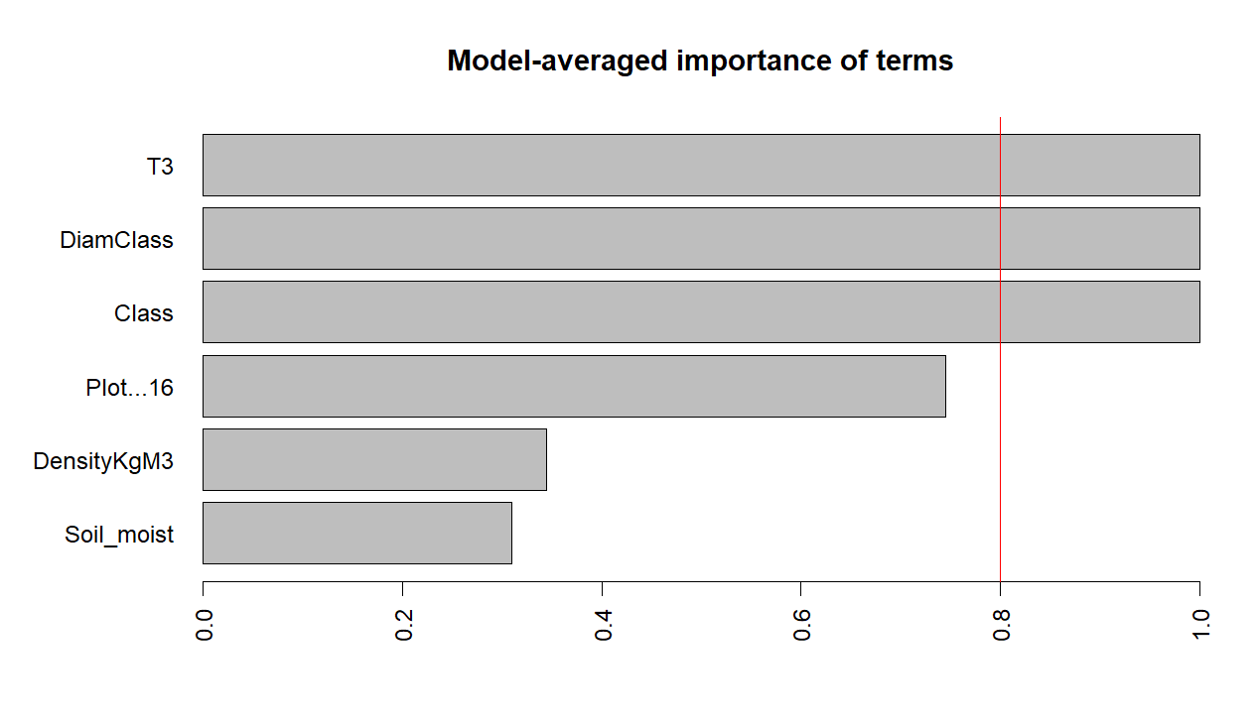
Estimate Std. Error z value Pr(>|z|) ci.lb ci.ub Importance
intrcpt -0.2886 0.0027 -107.6271 0.0000 -0.2939 -0.2834 1.0000
T3 0.0475 0.0028 16.8032 0.0000 0.0419 0.0530 1.0000
DiamClass 0.0235 0.0033 7.1545 0.0000 0.0170 0.0299 1.0000
Class 0.0148 0.0027 5.4583 0.0000 0.0095 0.0201 1.0000
Plot...16 -0.0039 0.0031 -1.2399 0.2150 -0.0100 0.0022 0.7454
DensityKgM3 -0.0010 0.0020 -0.4992 0.6176 -0.0048 0.0029 0.3443
Soil_moist 0.0005 0.0013 0.4176 0.6763 -0.0019 0.0030 0.3098

